Design ripple carry and carry lookahead (CLA) adders.
Ripple Carry Adder
Design a 16 bits adder electronic circuit using cascading one-bit full adders connected in cascade (seen in the class). This type of adder is called Ripple Carry Adder with the carry output from each full adder connected to the carry input of the next full adder in the chain.
- Use optimization techniques to use a minimal number of gates.
Assuming the delays given by the gates is as follow:
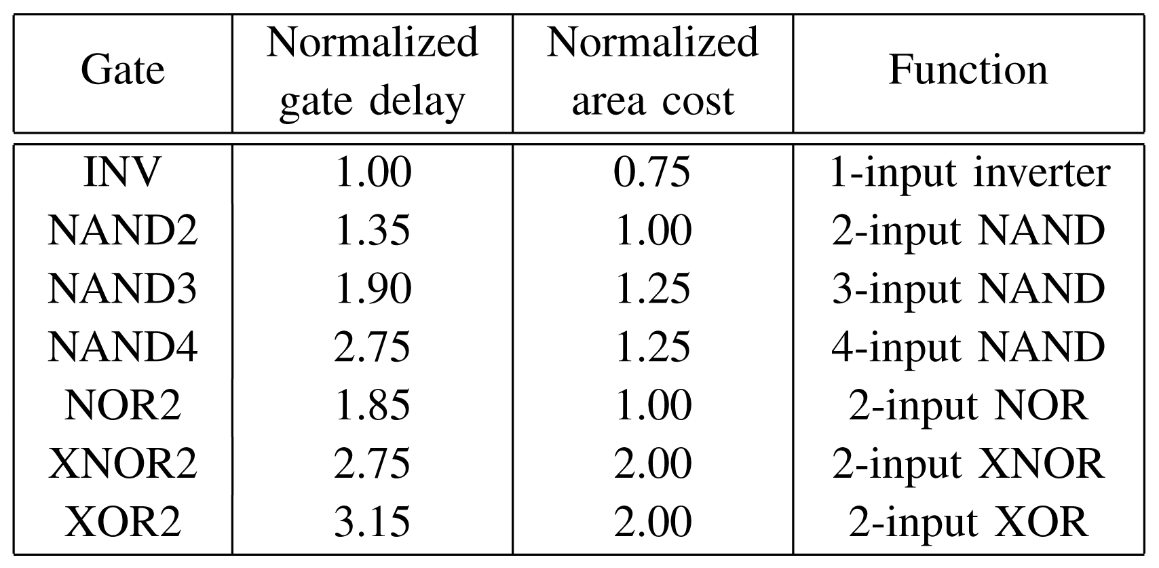
Calculate Delays for the outputs of a 16-bit ripple carry adder normalized to an inverter delay.
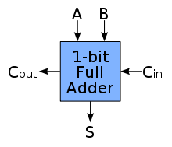 One-bit full adder
Carry lookahead adder (CLA)
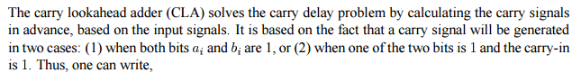
Write a Boolean function of Ci+1 and Si based on above assumption.
Design the one-bit lookahead adder and the full implementation of the 16 bits lookahead adder.
Calculate the time for the 16 bits addition operation using lookahead carry.
How would one implement a 64 bit lookahead adder using the 16 bit lookahead adder circuits?

